How do food molecules reach our muscles?

How Your Digestive System Works
We all know that our muscles need food. For example, sugars and fats provide the energy for our muscles to contract. Proteins are needed to build and repair our muscles. But, how do food molecules reach our muscles?

To find out, watch “The Digestive System” (https://www.youtube.com/watch?v=eSGRpPcJGlA). Use the information in the video to answer questions 1-3.

1a. Describe the main functions of your digestive system. | 1b. Why is this function needed to get digested food molecules to your muscles?

2. Complete this table.

Molecules that are in the food we eat | Digestion | Molecules that are absorbed into the blood

3. What is the main function of enzymes in the digestive system?

Enzymes can only work on molecules on the surface of food particles. The figure shows how breaking food into smaller particles increases total surface area. Thus, breaking food into smaller particles exposes more food molecules to the action of digestive enzymes.

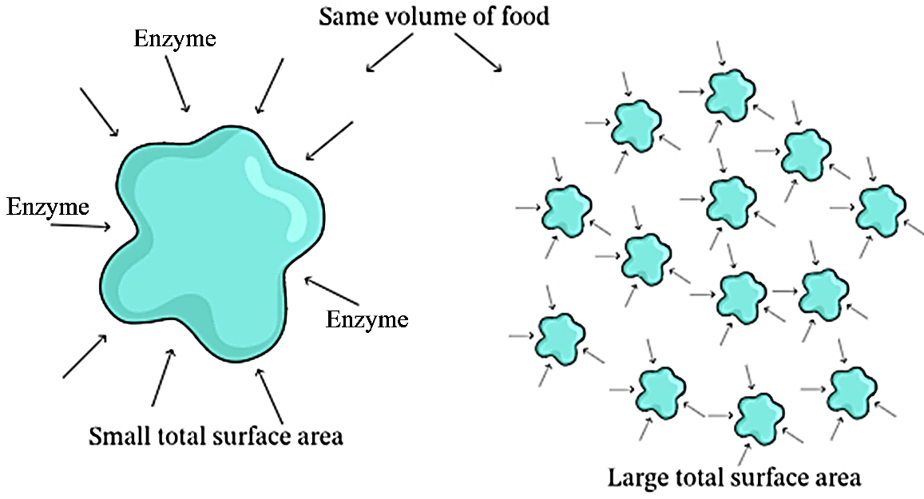
The organs in your digestive system work together to break down food into small molecules that can be absorbed into your blood. Then, your blood carries the digested food molecules to muscle cells all over your body.

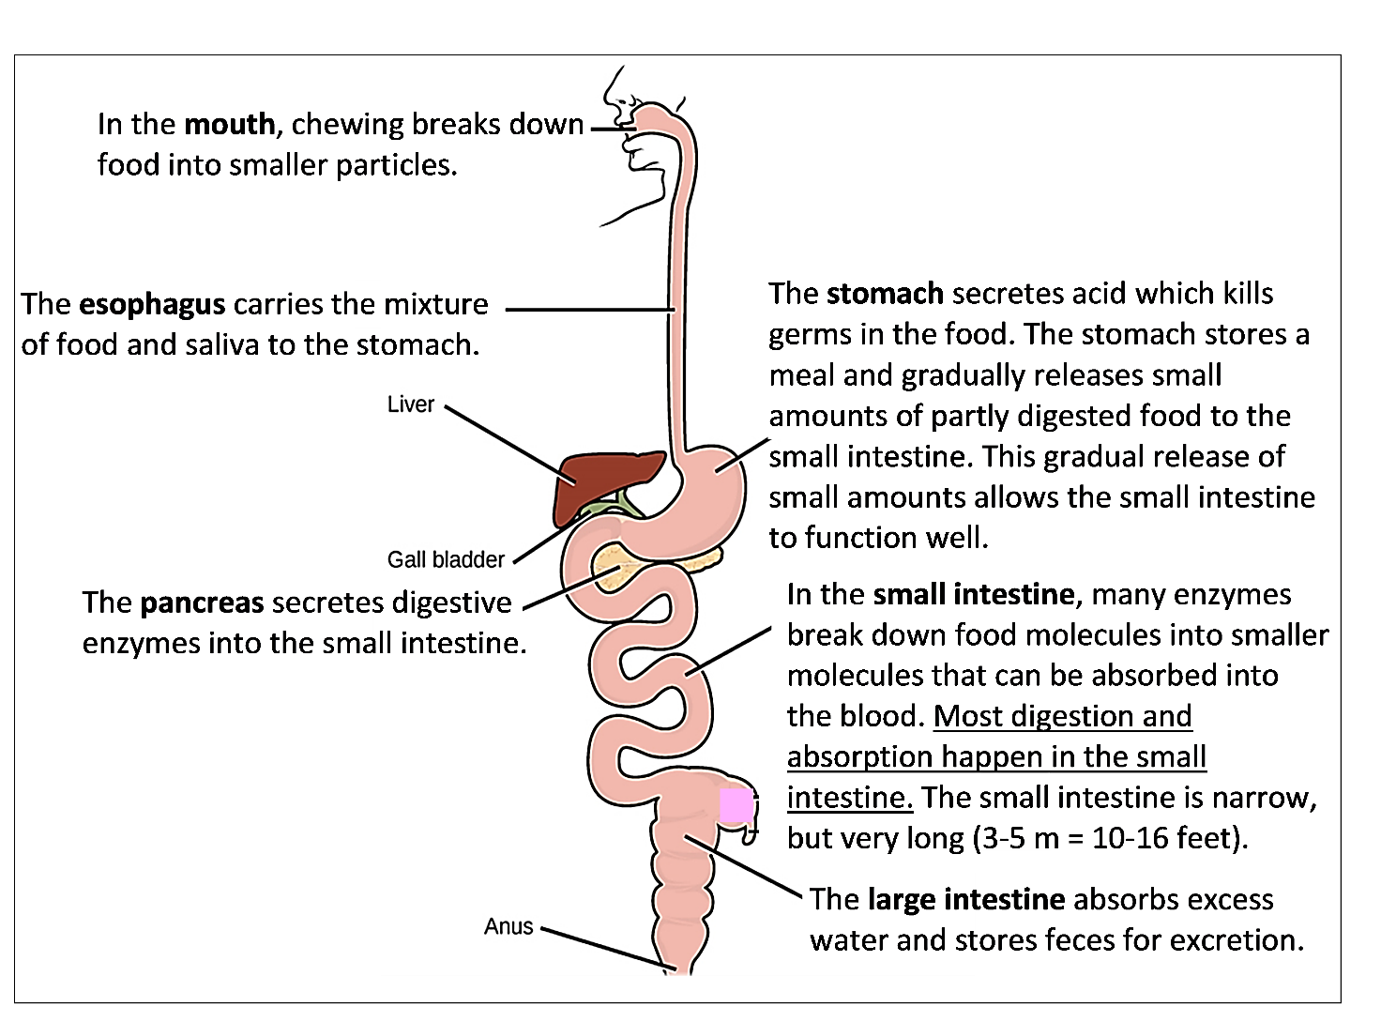

The above figure clearly shows the order of the organs in your digestive system. The figure to the right gives a more realistic picture of the positions of these organs in your body.  Structure and Function in Your Digestive System  4a. In your digestive system, efficient function depends on having each organ in the correct order from beginning to end. Why is it useful for food to be chewed in the mouth before it enters the small intestine? (Hint: See figure and explanation on page 1.) | 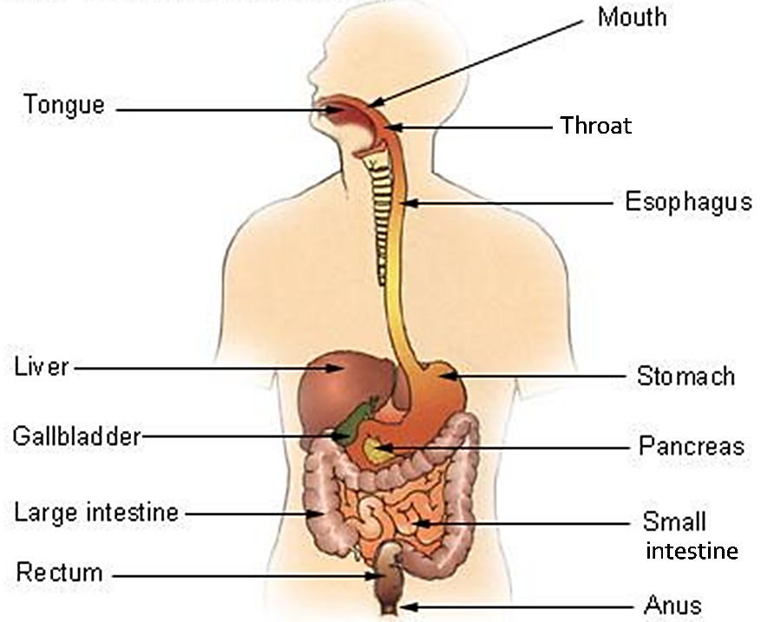

4b. Why is it beneficial to have the stomach before the small intestine? (Hint: When too much food enters the small intestine too quickly, this can cause problems.)

In response to the previous question, you analyzed how the efficient function of your digestive system depends on one aspect of its structure (the sequence of its organs). On this page, you will learn how the structure of your small intestine supports one of its major functions (absorption of digested food molecules into the blood).

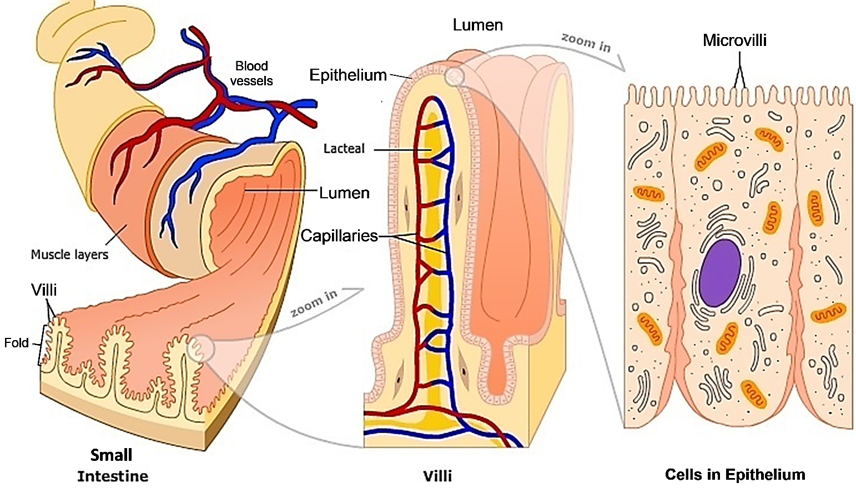

5. In the figure above, circle each term that is underlined in the bullet points below.

- The lumen is the space inside the small intestine. After a meal, the lumen contains a mixture of digestive enzymes with partly digested food molecules.
- The epithelium that lines the lumen of the small intestine has a very large surface area. This large surface area is due to the length of the small intestine and its folds and many villi. The surface area for absorption is further increased by the microvilli on the lumen side of the cells in this epithelium. The very large surface area of this epithelium increases the rate of absorption.
- Inside the villi are networks of capillaries (the smallest blood vessels). Digested food molecules move into the blood in these capillaries. Then, the blood carries digested food molecules near to every cell in the body, including muscle cells.

6a. How do the many villi and microvilli contribute to the function of the small intestine?

6b. How do the capillaries inside the villi contribute to the function of the small intestine?

Your Digestive System and Circulatory System Work Together.
7a. Substances cross capillary walls by diffusion. This figure shows that digested food molecules can diffuse into or out of the blood.  - Label the appropriate arrow with an si to show the direction of diffusion of digested food molecules across capillary walls in the small intestine.  - Label the appropriate arrow with an m to show the direction of diffusion of digested food molecules across capillary walls near muscle cells. | 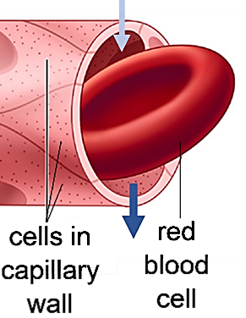

7b. The structure of capillary walls gives an example of the general principle that structure is related to function. Capillary walls consist of a single layer of flat, thin cells. Explain why this structure is useful for the function of capillaries. (Hint: Diffusion is relatively rapid over very short distances, but slow over longer distances.)

Your circulatory system includes:  - your blood, which carries dissolved molecules and red blood cells;  - your heart, which pumps your blood; and  - your blood vessels, including your capillaries, arteries, and veins.  8. Explain how your digestive system and circulatory system work together to bring molecules from your food to your muscles. | 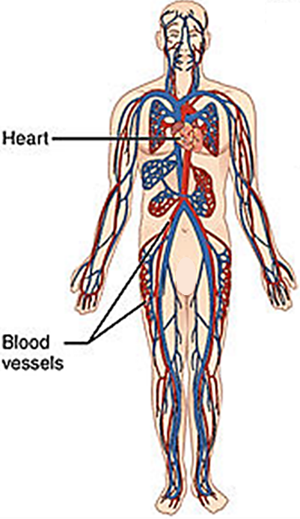

This is an example of the general principle that organ systems cooperate to accomplish needed functions in your body.

9. A biological structure often contains many repeats of a smaller structure within it. Give several examples of a biological structure and the many repeats of a smaller structure within each of them.

Structure and Function – Making an Argument
10. Complete the table below to make an argument that evaluates the claim that
“The structure of cells, organs, and organ systems is related to their function.”
Structure includes:
- the shape of an organ or cell
- the parts of an organ system, organ or cell
- how these parts are organized.

Examples | Evidence –  Describe one or more features of the structure. | Evidence –  Describe the function. | Reasoning –  Explain how the evidence supports (or contradicts) the claim.
Cells in capillary wall

Organ –
Small intestine

Organ system – Digestive system

Strengths of the Evidence that Supports the Claim

Limitations of the Evidence for the Claim

By Dr. Ingrid Waldron, Biology Department, University of Pennsylvania, © 2025. Teachers are encouraged to copy this Student Handout for classroom use. This simpler Student Handout, a more complete Student Handout, and Teacher Notes (with instructional suggestions and biology background) are available at https://serendipstudio.org/exchange/bioactivities/SFCellOrgan.

